SCREEN FREE BUS
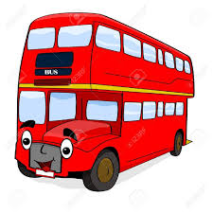

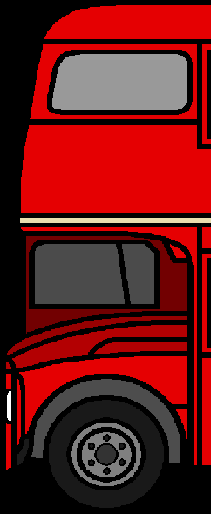
Note to teacher: put front of the bus on the classroom wall. Hand out the screen-free activity sheet to pupil. Once all screen-free activity sheets are completed by pupils add to the classroom wall and finish off with the back of the bus. You then have your screen-free bus full of ideas!
Screen-free activity sheet Name:
Directions: Every time you choose an activity at home that doesn’t use a screen (for example, reading, drawing, dancing, playing outside), just write down or draw a picture of the activity on the passenger car.

