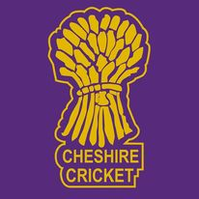
Cheshire Cricket Board
Coaching in Schools
Session by AJ, Owen, and Tom
andrew.jackson@cheshirecricketboard.co.uk or call 07807 522 823

At Cheshire Cricket we want to offer you the opportunity to access sessions that will develop your children’s fundamentals of movement as well as cricket specific skills, in some FUN, ENGAGING sessions for ALL.

What we offer:
All Year-round Cricket Curriculum sessions available, adapted for each class KS1 and KS2
After School Clubs available
Teacher CPD alongside lessons, or in separate CPD events
Current sessions take place following all local and sport specific guidance relating to Covid-19, with kit sanitised regularly.

Who we are:
All coaches hold a minimum of a UKCC2 qualifications in cricket and have worked in many different schools
Coaches also hold Multi Skills qualifications if school would rather multi skills in the winter and cricket in the summer.

How Much:
Costing Options…
1) Full morning – at least Two curriculum lessons = £60
2) Full afternoon – at least Two Curriculum lessons = £70
3) All Day – at least 4 lessons = £100
4) Afternoon and After School Club – at least Two curriculum lessons and ASC = £110
5) Full day – at least 4 lessons and ASC = £140
** Special offer in Autumn Term 2 (November to December) pay for 4 weeks coaching get 2 weeks free **

