October Offers from Happy Kids Yoga
Do you want to bring mindfulness into your school, not only for the kids but also for the staff? I have pulled together some great products for you in October to really make mindfulness an integral part of your school. Mindfulness is so important at the moment it supports our mental health, makes us more resilient and also helps us to cope with change in a better way and we all need that.
1. 10 Day Mindfulness Experience for Teachers
We have created a programme for teachers and professionals showing them how to bring mindfulness into their lives whilst still fitting around their busy working day.
The benefits of mindfulness for teachers:
- Stress and anxiety management
- Supports teacher’s mental health
- Helps teachers manage change and be more resilient
- Improves teamwork
- Improves communication with students
- Helps us set up a positive learning environment
What you will receive with the Happy Mind Collective Program:
- 10-day mindfulness course - 15-minute video per day
- Live, virtual or recorded introduction to the course
- Additional resources including guided meditations & yoga sessions
- Daily reminders and motivational messages
- Suitable for beginners, no prior experience required
St Andrews Primary School in Warrington have just completed the course and I received this comment from the headteacher:
"Thanks Jen for your input during our Inset day - it certainly set the right atmosphere for moving forward. Your daily mindfulness sessions have really helped me deal with the stresses of this unpredictable and chaotic time. I would recommend Jen to anyone trying to find some moments of peace during busy days."

Check out the video below for a bit more information - https://youtu.be/AfHb8guDaB4
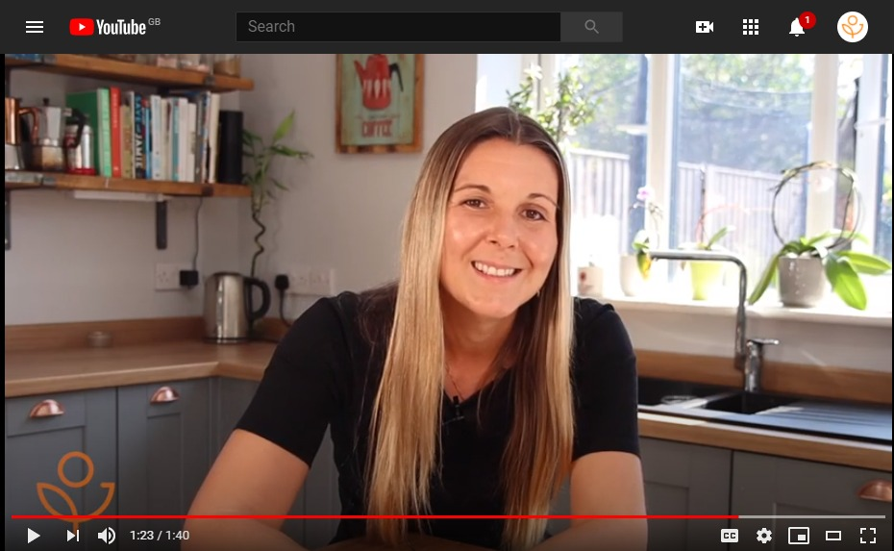

2. Yoga and Mindfulness for the Classroom
The hour and a half long session shows teachers how to bring yoga and mindfulness skills into the classroom every day. It is a fantastic follow on to the 10-day mindfulness for teachers course as once the teachers have a basic understanding of mindfulness, it's much easier for them to show the kids.
These skills will help children feel more confident, calm and also increase concentration levels. In addition to this, it gives children the skills to manage their own mental health challenges now and in the future through breathing, relaxation and movement.

3. Yoga Sessions for the Kids
Over lock down we built up an array of recorded yoga classes for EYFS, KS1 and KS2 along with daily 5-minute mindfulness videos. We can offer you 6 weeks of sessions to use in school or to be sent home for kids. Yoga and mindfulness have so many benefits for kids in these chaotic time including, building positivity, confidence and creating empathy for others.
Here is an example of one if the 5 minute videos - https://youtu.be/CnxDaOEvM1A
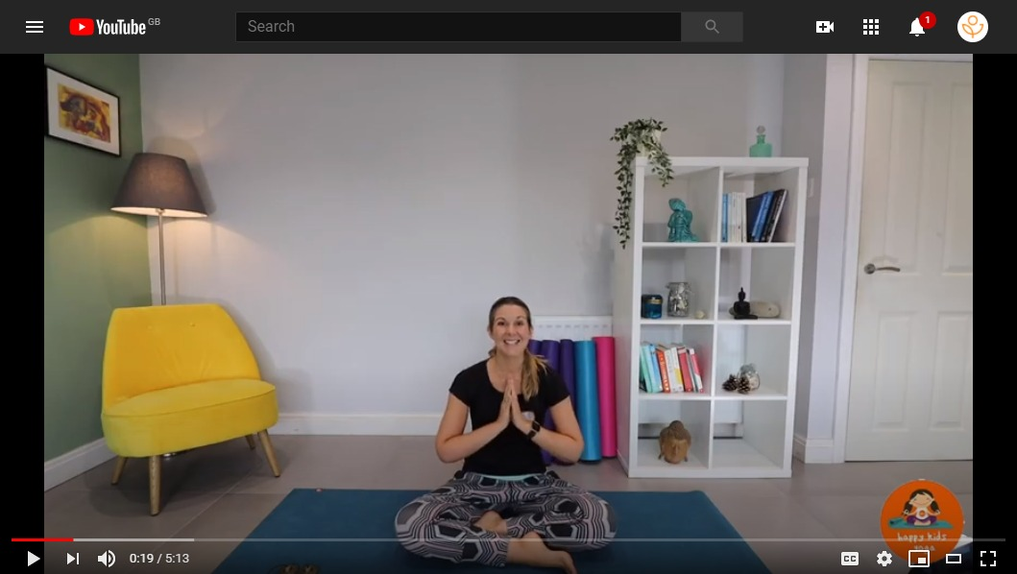

I am also teaching classes in person at Bradshaw Lane Primary and St Andrews Primary weekly. If you would like me to come into your school or take up any of the offers above, please do get in touch.
You can contact me either via email jen@happykidsyoga.co.uk or give me a call on 07515273647.
Thanks and look forward to hearing from you.
Jen xx

